Press Release
Humane activists from around the world will gather for an event in Athens Greece on Saturday, May 20th at 12 noon at Syntagma Square and at 6 pm at the Olympic complex to actively protest what has become a nationwide witch hunt aimed at destroying animal welfare in Greece.
Threats of physical harm and legal action against advocates are rampant, personal computers have been seized, animal advocates tossed in Greek jails and their animals confiscated.
For years, Greek and foreign animal welfare organizations have been battling brutal animal abuse and neglect and now they are rightfully battling the very law that is supposed to protect animals in Greece. Humane legislation 3170, passed in 2003 by the Pasok Parliament is seriously deficient in quality issues and sensible protection. Convoluted and confusing, 3170 and it’s rare pursuit by officials, is causing a backlash of horror for those animal lovers attempting to rescue and re-home tens of thousands of Greece’s neglected, abandoned and abused animals.
The statues mandate that local authorities be responsible for abandoned dogs, their vaccination, sterilization, identification, re-homing or spay/neuter and release programs. Purportedly funding for these projects was dispersed for action programs. Yet, 3 years later only 29 of nearly 1,000 municipalities and communities in Greece have initiated humane programs. The result is devastating. Tens of thousands of abandoned dogs wander the streets, starving, multiplying and becoming the victims of poisonings or random attacks of horrifying abuse.
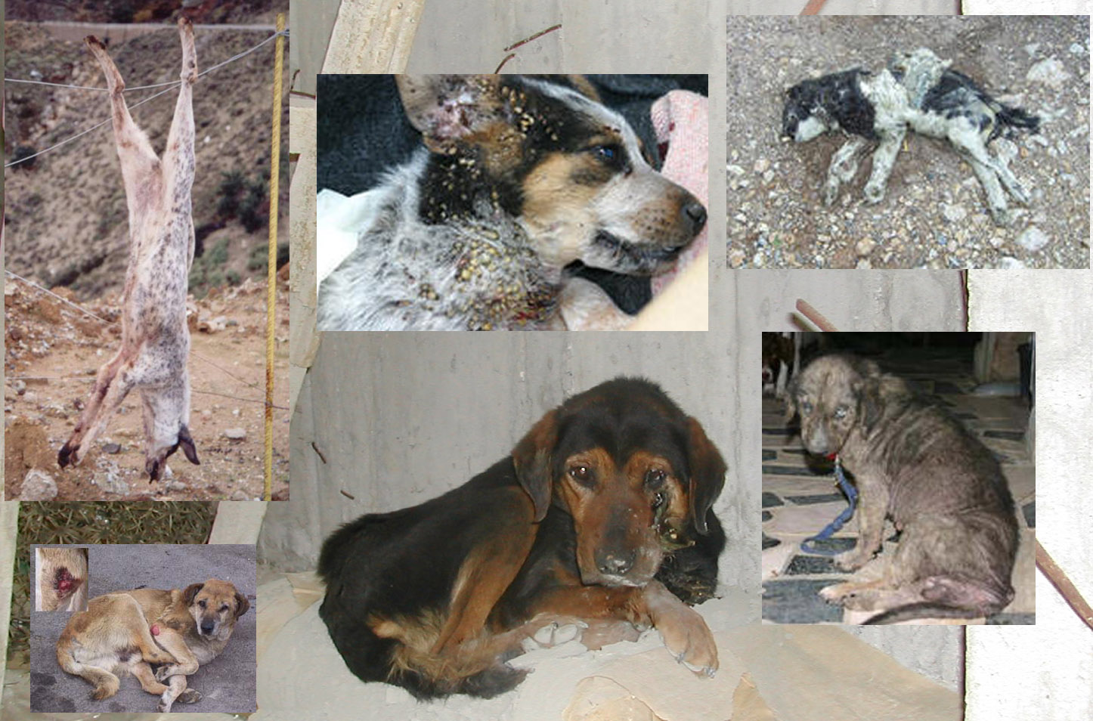
Humane advocates are being accused of dealing in illegal transport and dog trafficking to experimental labs for commercial gain. There is no proof or one shred of evidence to support these ludicrous allegations and all court hearings have indeed been won by the defendants who have been forced to endure defamation of character and humiliation.
Sympathetic veterinarians are threatened with loss of license for participating in re homing procedures to loving families in Europe and dogs on their way to these homes have been confiscated and frighteningly have disappeared. The true victims of this senseless campaign are the animals.
An amazing amount of energy has been put into throwing suspicion on animal welfare groups. If the same amount of energy was put into actually solving the massive animal welfare problems, the future would look a whole lot brighter for the suffering animals of Greece.
The law must be amended or repealed and safe passage of animals in transport from Greece to homes within the European Union or North America must be facilitated and not sabotaged. The relief, rescue and care of abandoned animals by humane advocates must be legalized and facilitated by government bureaucrats.
It is time to cooperate and support Greek and foreign animal welfare organisations, not crucify them and the animals they love..
12th May, 2006
Signed:
Arche Noah Kreta, Germany – www.archenoah-kreta.com
Achiac Society for the Care of Animals, Greece
Aesops Friends of animals, Greece – www.aesops.gr
CHANS, Sweden – www.chanshund.com
CIDAG, Greece – www.atlantisnet.gr/cidag
Danish Friends of Animals, Denmark – www.dfas.dk
Graeske Hunde, Denmark – www.graeskehunde.dk
Greek Animal Rescue, Canada – www.greekanimalrescue.com
Greek Animal Rescue, England – www.greekanimalrescue.com
Kalamata Animal Welfare Society, Greece – www.kaws.info
Kefalonia Animal Trust, Greece – www.kefalonia-animal-trust.org
KI.DI.ZO. (Movement for Animal Rights), Greece
Strays.gr Fight for Animal Life, Greece
Stichting AAI, Holland – www.stichtingaai.nl
SPAZ Society for the Protection of Stray Animals, Greece – www.spazgreece.com
WAG Welfare for Animals Global, USA

